1.When account in locked status, then enter the same mail address and click forget password button, page moves to verification page and mail id displayed wrong details. But page should not move to verify page and need to show account locked message.

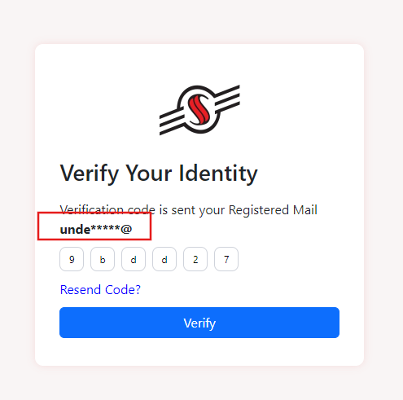

1. In reset password, when confirm password enter wrong value, the message displayed wrong sentence, it need to show “New and Confirm must be same” or any other valid message.

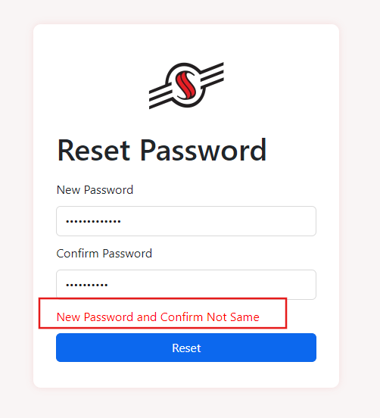

1. When enter registered mail id and click forget password button, page navigates to verification page and enter valid verification code and click verify button and page navigates to Reset page and enter valid new and confirm password page and click reset button and page navigates to login page and enter same mail id and click forget password button page directly navigates to reset page instead of verification code page.
2. When enter invalid token in Two Step Verification page, page doesnot show any alert message and verify button display loading status and it won’t change.
3. In Reset page, previous password able to enter and page accepts the previous password.